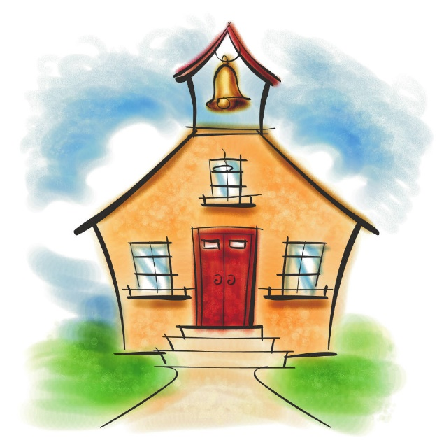

**Pre-Schools**

**Blue Hill Montessori, Canton**

**The Campbell School, Milton**

**The Carriage House School, Milton**

**The Centre School, Milton**

**The Children’s Center at Milton Academy, Milton**

**The Discovery Schoolhouse**

**Learning Circle Pre-School, Milton/Canton**

**Sunshine School, Milton**

**Thacher Montessori, Milton**

**The Village School, Milton**

**Wollaston Hill Montessori, Quincy**